In August, some of our learners from the Malindela Baptist learning group participated in an education awareness campaign.Together with the EAGLE team, they went around the Malindela neighborhood handing out flyers to local residents and telling them about EAGLE. Many people seemed not to know about EAGLE and were surprised to hear about it during the campaign. It was encouraging to hear parents praising the work of EAGLE and promising to bring their children to join the learning group. And it was exciting to see the learners confidently telling people about EAGLE without the help of an EAGLE team member.
One lady could not believe an offer like the one EAGLE has exists. She said, “There is nothing like that in Zimbabwe” and the team responded, “There is something like that in Christ!” The campaign proved not to be only about education but also sharing about Christ and his love for his children, which is why EAGLE is offering this opportunity to young people.
It is impressive seeing the EAGLELITES pushing the Kingdom perspective without being instructed to by any of their leaders.

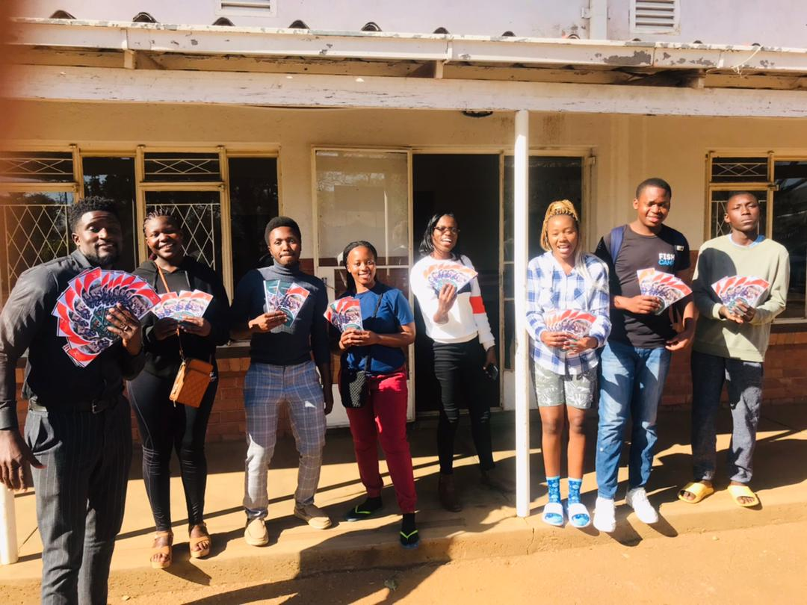
Malindela team ready to give out brochures

